Covid-19 NGO WORKING GROUP
Survey Results

Groups who participated in the survey:
- Pobal
- BelongTo
- Dublin City Community Co-op
- Community Work Ireland
- OneFamily
- Pavee Point
- National Collective of Community Based Women’s Networks
- Irish Network of the Unemployed

General review of the group’s work and path forward:
We asked participants to consider the work done by the group to date and if and how the group might continue going forward
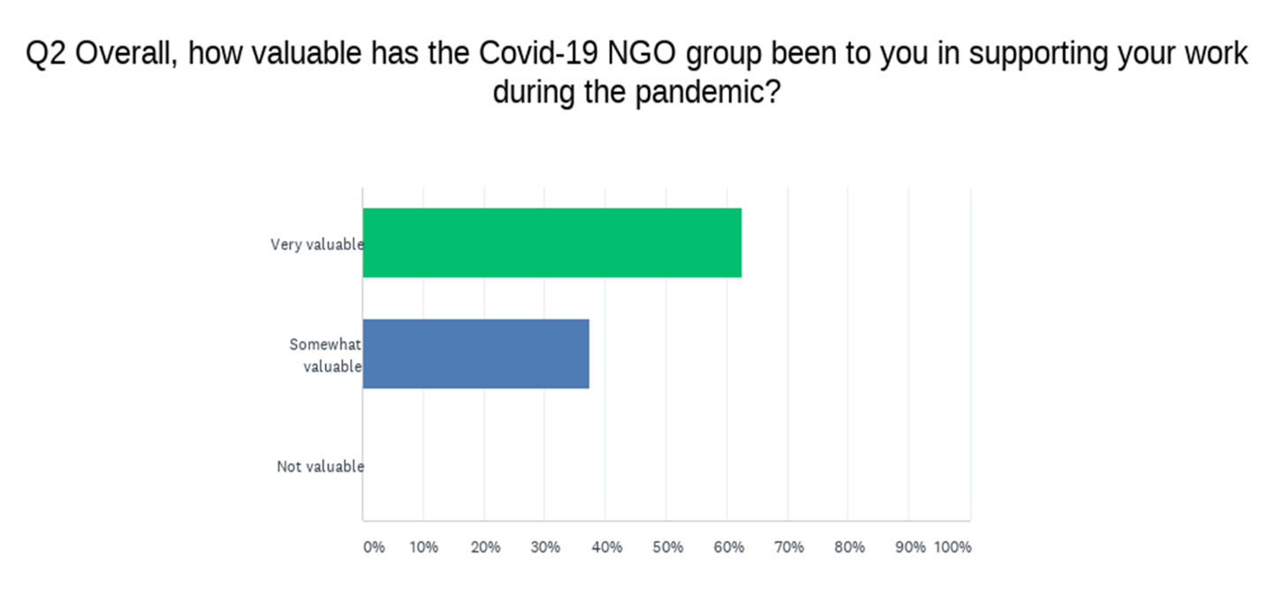
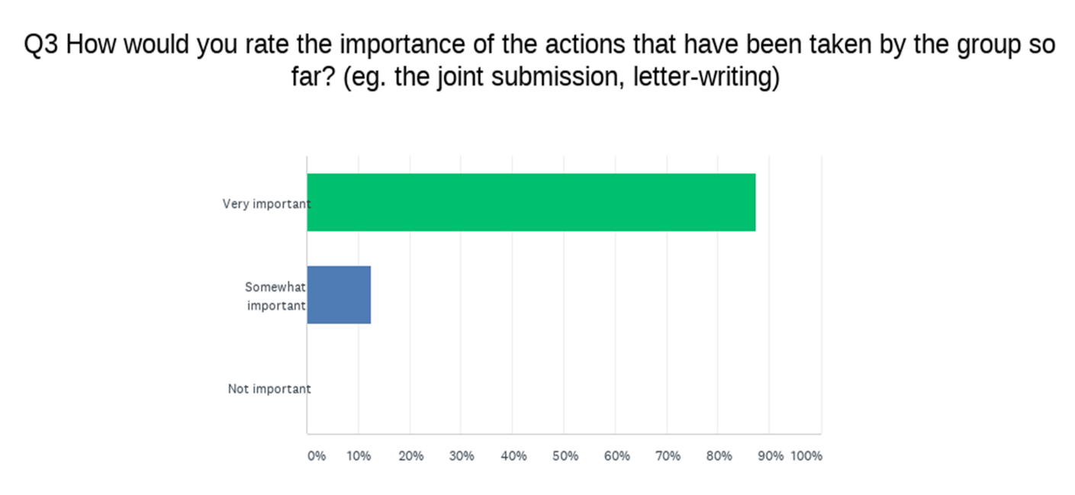
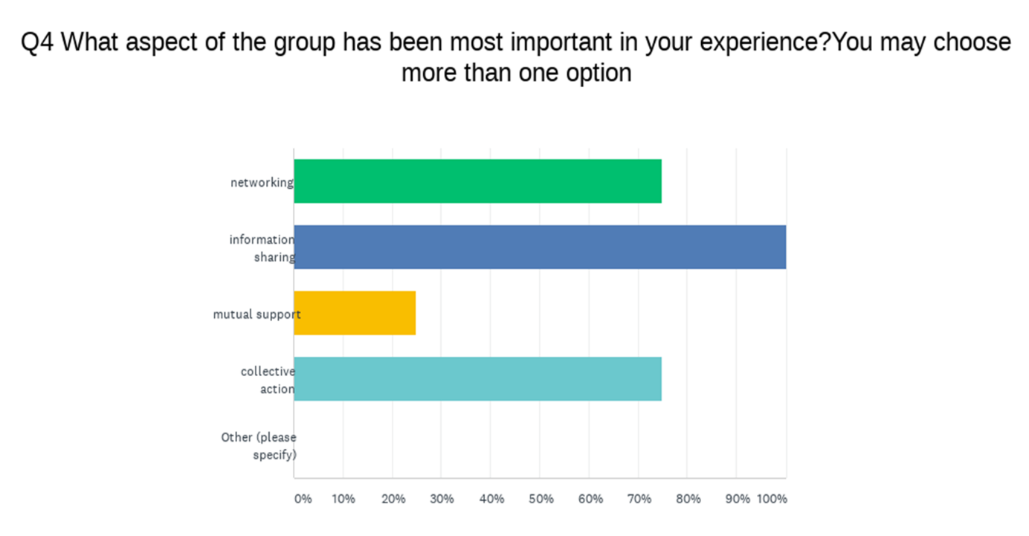

What has worked well for the group so far?
- Learning how other NGO’s are approaching issues
- Willingness to undertake short, focused pieces of work
- Rapid and regular updates
- Information sharing
- Opportunity for joint actions
- Support and leadership of CWI
- Networking

What could be improved for the group?
- Max and hour for meetings
- Clarity regarding terms of reference
- Consistent attendance and identity of group
- More groups joining
- Communication methods for group to interact as issues arise

What is the main purpose of the group going forward?
- Lobby on common issues arising post-pandemic
- Advocacy on the impact of COVID-19 on the most disadvantaged
- To network and share information about the impact of COVID-19
- To catch issues not elsewhere identified and raise them with policy makers
- Collective action to improve outcomes for disadvantaged communities

What actions should the group take going forward?
- Supports for Direct provision lobbying
- Approaches to central government re budgets
- Maintain a focus on need to include community development and human rights in responses to pandemic and perhaps link with relevant cross border issues post Brexit
- Use the work to highlight the need for a socio-economic status ground in Ireland's equality legislation.
- A new scheme to support community organisations
- Schools; childcare; mortgage supports; DV; court delays
- Actions to ensure representation on relevant decision/policy for a
- research, report publication, media
- Review of specific positive impacts to benchmark effectiveness

Other organisations that should be invited to the working group:
- Groups working on the ground
- Local groups
- Link with Northern Irish organisations working with marginalized groups

How often should the working group meet?
- Fortnightly
- Monthly (most common answer)
- Every 6-8 weeks
- Depends on developments with COVID-19 guidelines

Review of the implementation of the recommendations in our joint submission:
We asked participants to consider the recommendations of the submission and answer whether, in their experience, the recommendations had been fully, partially or not at all implemented
General Recommendations:
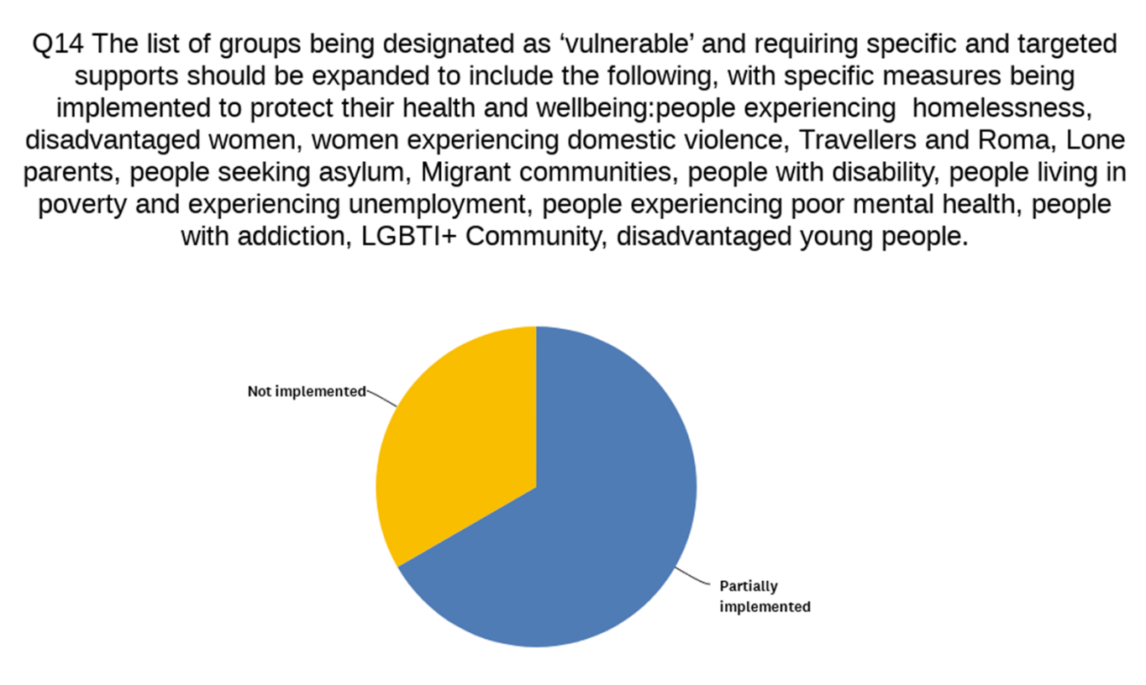

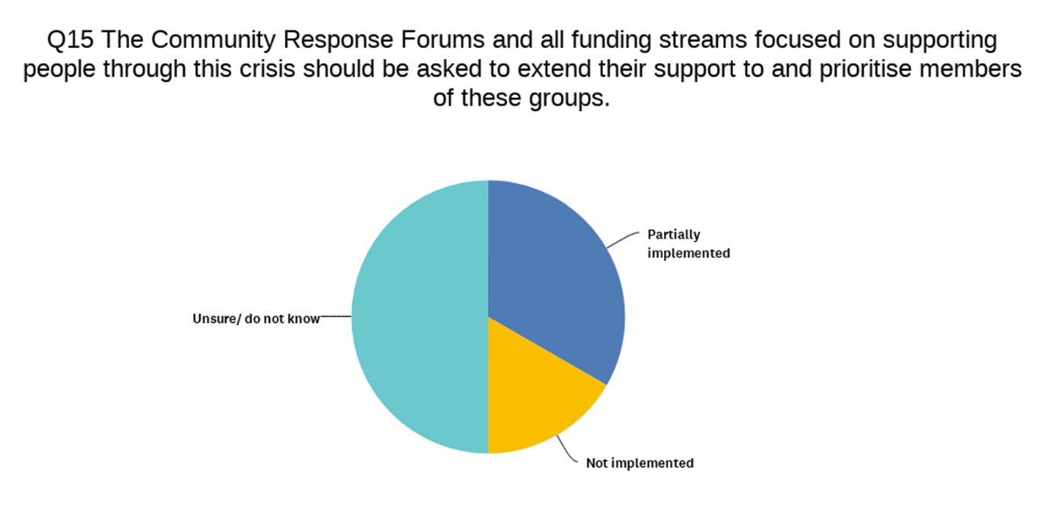
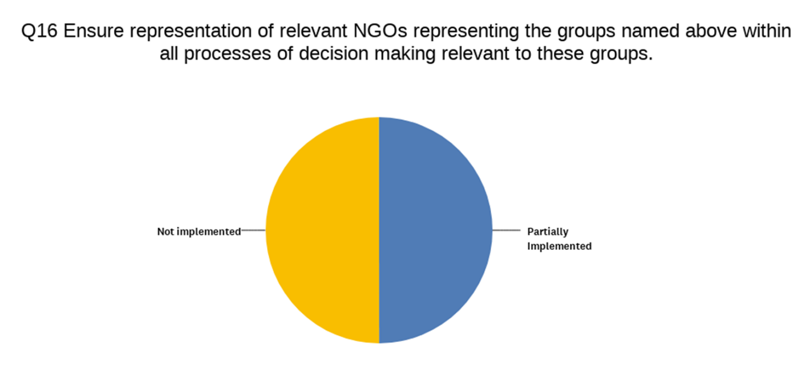
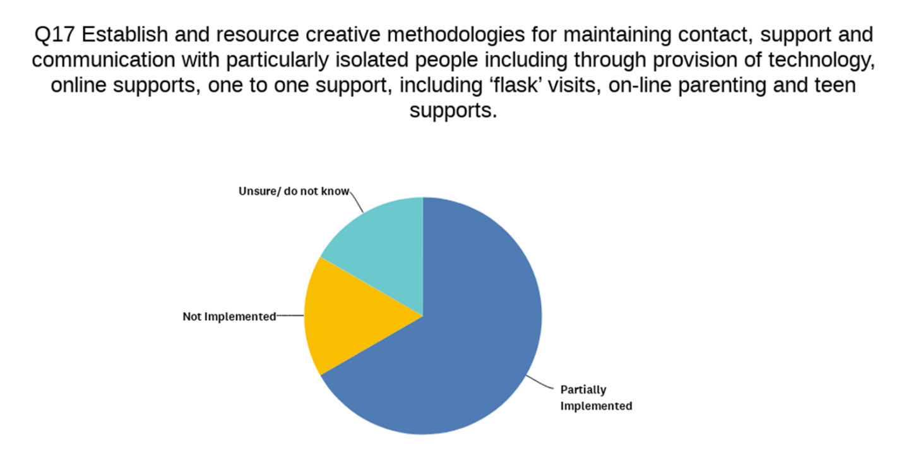
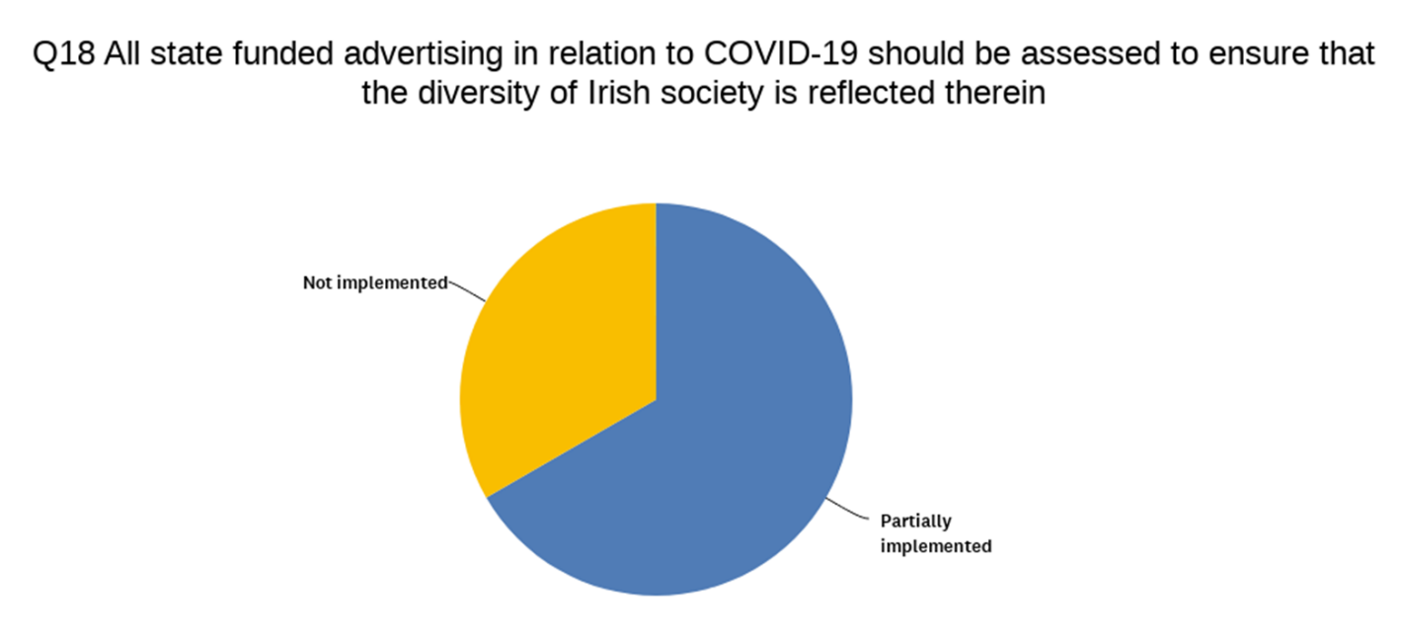
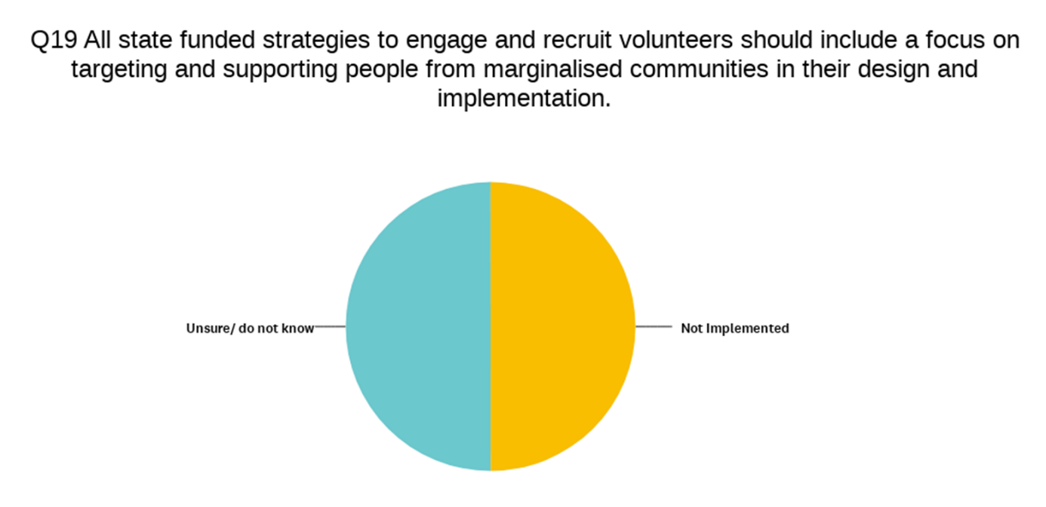
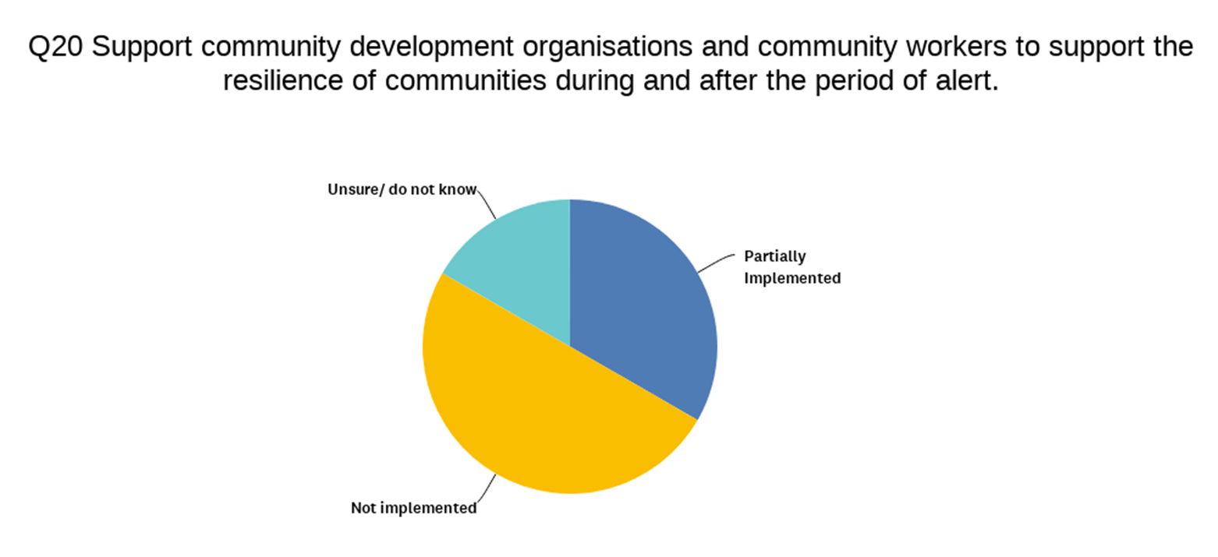
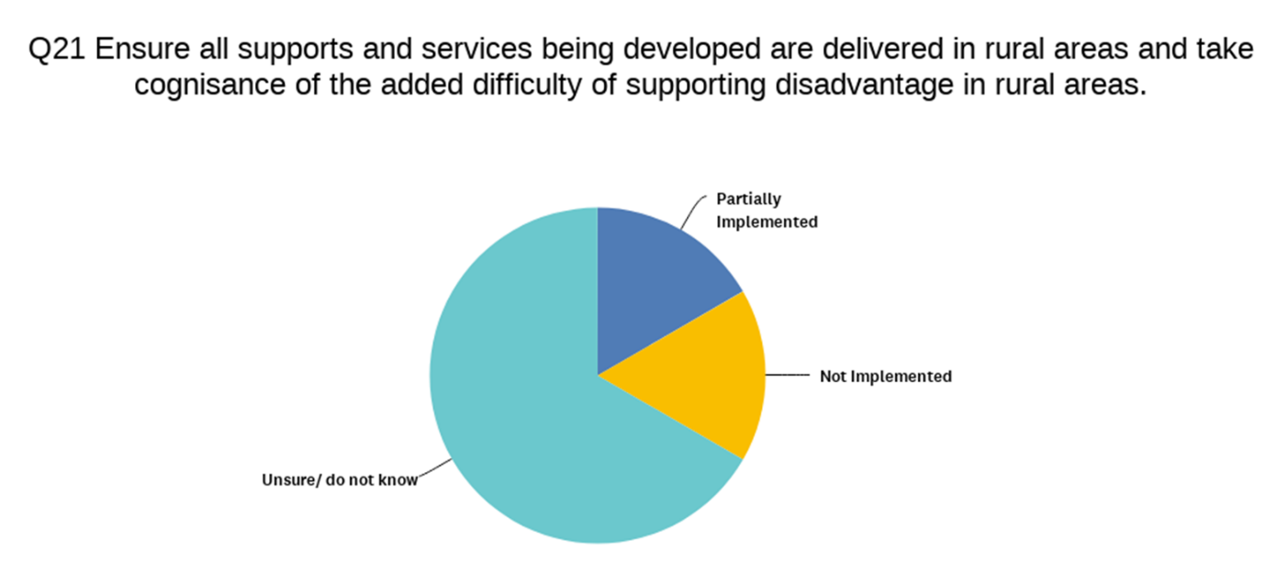

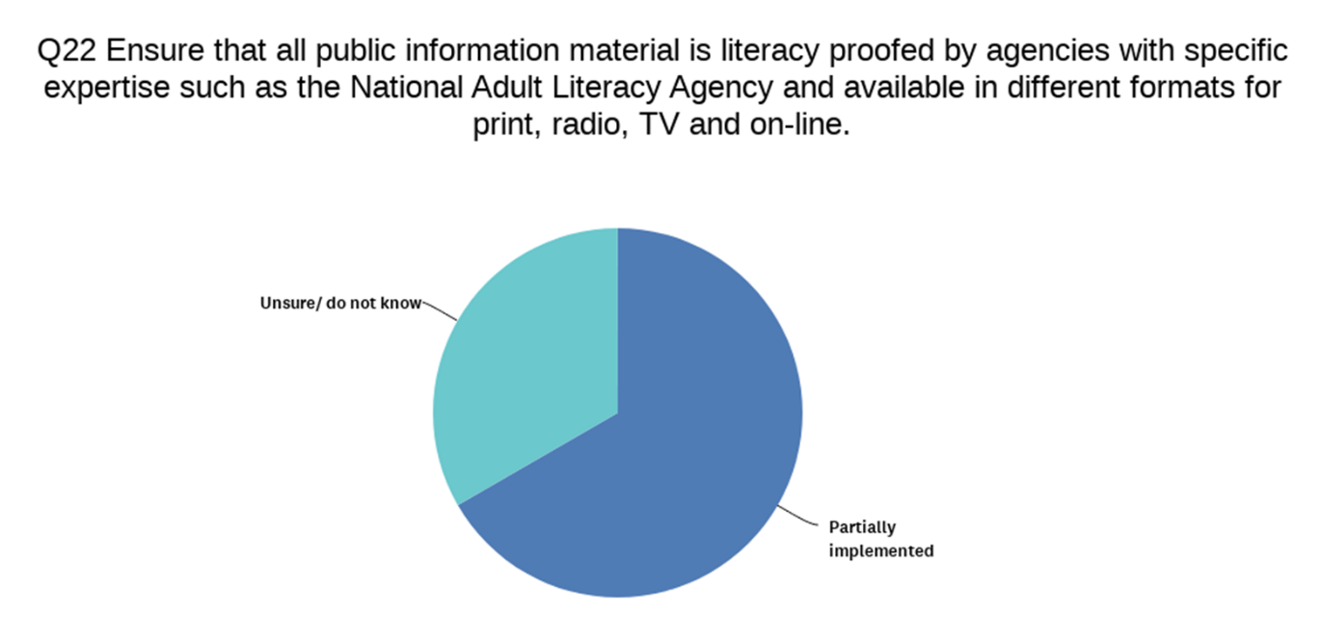
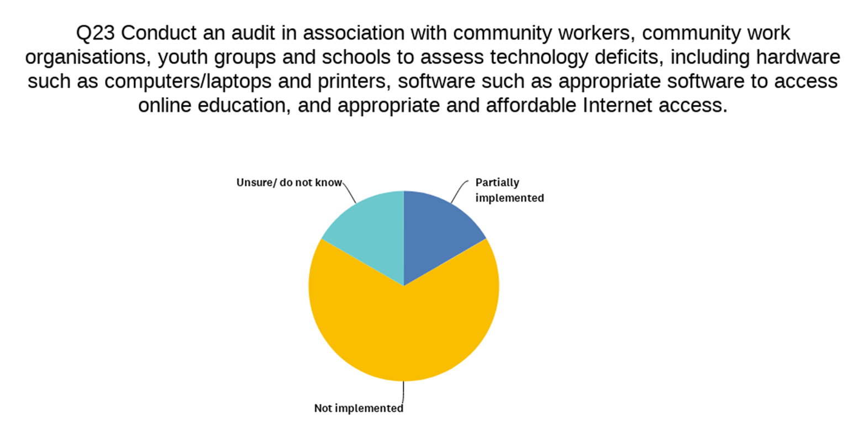
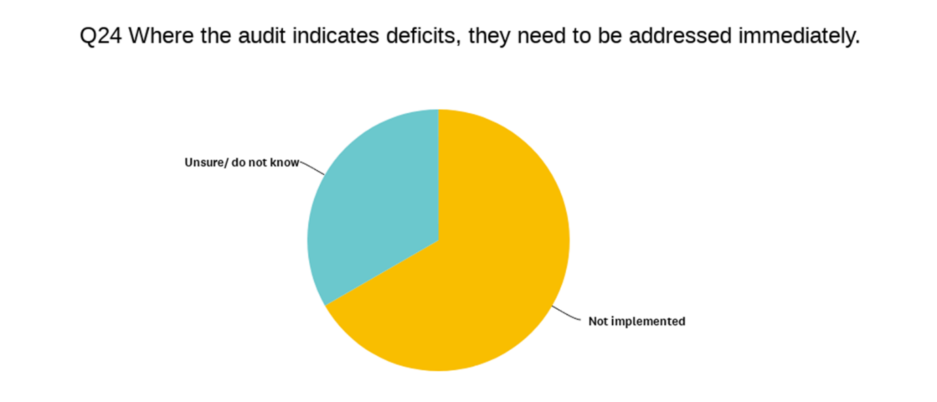

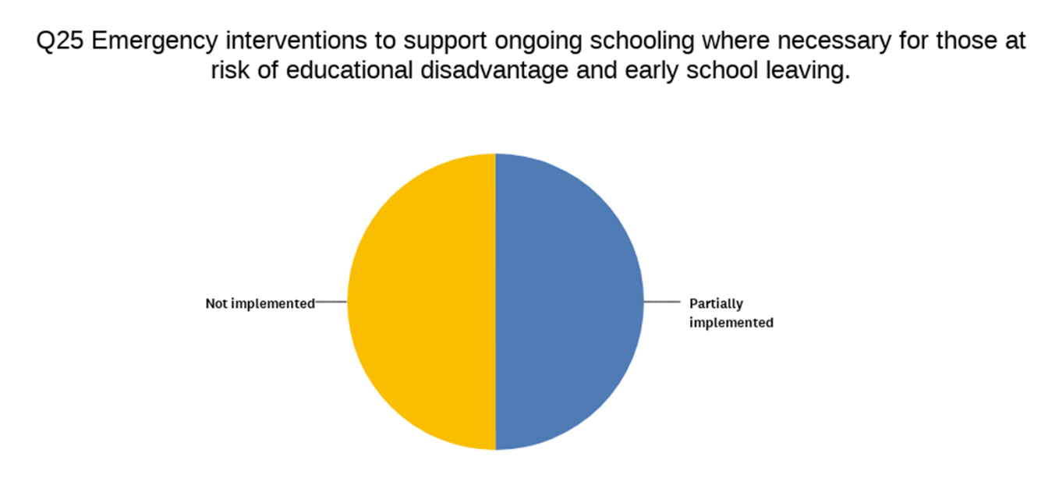

Recommendations relating to the LGBTQ+ community
LGBTI+ organisations offering frontline services continue to be resourced to provide and adapt existing supports to reach people in their own homes. | Partially implemented
Ongoing monitoring of the uptake and issues facing the LGBTI+ community, especially those most vulnerable | Partially implemented
LGBTI+ organisations continue to be supported by the state and access core funding in order to enable a coordinated response by LGBTI+ organisations to the pandemic. | Partially implemented

Recommendations relating to poverty and unemployment
Greater clarity needs to be given on how C19 PUP interacts with the existing social welfare system | Partially implemented
Serious consideration must be given to additional income supports for people who are already on a social welfare payment, in effect a Spring / Summer bonus, though it should also be paid to people on a Jobseekers payment for less than 15 months. | Not implemented
A longer-term solution is needed to benchmark welfare supports so they are adequate to lift people above the poverty line and provide them with a Minimum Essential Standard of Living. | Not implemented
Given the complexity of Ireland’s social welfare system on-going clarity is required as to how exactly C19 PUP and Jobseekers payments are and will interact. | Not implemented
An extension to the fuel allowance in recognition of increased fuel costs due to “Lock down” and people spending longer periods at home. | Partially implemented
Provision of a once-off payment to those solely reliant on the state pension and people living with a disability. | Not implemented

Recommendations relating to the Traveller and Roma community
Implementation of ethnic equality monitoring in routine health administrative systems, including those related to COVID-19. | Partially implemented
Full implementation of COVID-19 Department of Housing Circular to all Traveller accommodation. | Partially implemented
Department of Housing, Planning and Local Government to withdraw the 41/2012 Housing Circular | Not implemented
Ensure the provision of targeted and mainstream supports for Travellers and Roma who are advised to self-isolate and are unable to do so. Where possible a mobile/self-isolation hub should be brought in beside existing accommodation to allow Travellers to self-isolate beside family and community. | Fully implemented
Ensure the provision of transportation for Travellers and Roma who require a COVID-19 test to a testing centre or hospital where they cannot secure their own transport. | Fully implemented
Representation of Traveller organisations and groups representing Roma on newly established Community Response Forums which are being coordinated and convened by local authorities throughout the country. | Partially implemented
Department of Employment Affairs and Social Protection to ensure humanitarian response and special measures for particularly vulnerable Roma who do not have income and do not meet the Habitual Residence Condition to access social welfare payments. | Partially implemented
Department of Education and Skills to support and resource targeted measures to lessen the impact of COVID-19 on Traveller and Roma existing educational inequalities at all levels. | Partially implemented
Teachers and educational support workers to proactively support Traveller and Roma students and develop appropriate ways of supporting both students and parents to develop an at home programme. | Partially implemented
Ensure that post and current impact of COVID-19 on Travellers mental health is urgently addressed in partnership with Traveller Health Units, local Traveller organisations and Primary Health Care Projects, including ring-fenced funding to support peer-led targeted initiatives. | Not implemented
Department of Children and Youth Affairs and Tusla to make emergency domestic violence accommodation available in hotels and B&Bs. Ensure that such emergency accommodation settings can accommodate ‘households’ rather than ‘individuals’ as Traveller mothers may have adult children or other family members living on their yard or house. | Not implemented
Department of Justice and Equality and the Courts Service to urgently address and increase court sittings in Local District Courts so that at a minimum women are able to secure safety orders during this time. | Partially implemented
Increase visibility and effective responses by An Garda Síochána to domestic violence reports coming from Traveller sites and homes | Partially implemented

Recommendations relating to lone parents
SW supports to cover increased costs of staying at home– food and utilities, children may have received food in school etc., additional health care costs if people get sick, need to bulk buy goods | Partially implemented
Ensure that the mooted childcare system for frontline workers is extended to include all workers deemed to be at the frontline, including those working in vital retail and cleaning services as well as those working in refuges or other supported accommodation, allowing lone parents in these sectors to maintain their income. | Partially implemented
Tusla to be resourced to plan for lone parents who may become ill to support parents and ensure the best interests of the child are upheld | Do not know
Government, tech and communications companies should work together to ensure children and young people can access the equipment and broadband they need to stay connected with the world | Not implemented
As the household type most at risk poverty, a lump sum payment would go some way towards supporting parents to cover extra costs – a double OPF payment | Not implemented
Community Response Forums, retailers and An Post to include lone parents in their vulnerable groups list in order to access designated shopping hours and home deliveries in a similar way to older people. | Partially implemented

Recommendations relating to gender
Ensure childcare workers who work through this crisis are paid at least a living wage | Not implemented
Ensure hospital support staff (including healthcare assistants, cleaners) are paid at least a living wage and are supported with their childcare and other care needs to ensure they can provide vital services during the pandemic. | Not implemented
Ensure that those in the gig economy can access income supports | Not implemented
Ensure Early Years services in financial difficulty have ‘fast track’ access to the existing Early Years Sustainability Fund should they face financial difficulty due to the COVID-19 emergency. | Partially implemented
Ensure all workers have the required PPE to carry out their work safely | Partially implemented
In the absence of a strong social partnership system and comprehensive trade union representation, there is merit in forming an emergency body to engage in sectoral dialogue and negotiate protocols, starting with the worst affected sectors - restaurant, hotel, retail, and childcare sectors. | Not implemented
Tusla needs to allocate additional funding for refuge spaces for those experiencing domestic violence and plans for alternative additional refuge spaces so that they can practice physical distancing. | Not implemented
It is crucial that An Garda Síochána treat women living in abusive situations as a vulnerable group, and that safety and protective orders are enforced | Partially implemented
The current provision of emergency barring orders should be extended in this crisis to ensure women can access safety and protective orders outside of court settings, for example from a Garda station, as needed. | Partially implemented
The national awareness campaign on domestic violence should be continued for the duration of the crisis. | Partially implemented
The impact of COVID-19 on the birthing experience of every women should be kept to an absolute minimum and there must be clear ongoing communication to pregnant women outlining all developments in service provision and COVID-19 advice for pregnant women. | Not implemented
The roll out of free broadband to vulnerable groups as well as information ads on how best to use the internet, for those who are new to it. Any information campaign/public health advice and information needs to go via these channels as well. | Not implemented
Nationwide awareness bulletins or ads of benefits of social media aimed at those with least amount of technical and literacy skills to encourage them to use tools such as messenger and WhatsApp video. | Not implemented
Targeted information communication for those who are most vulnerable assuring level of care to all citizens and stop medical experts from talking about “Tough Decisions” scenarios. | Not implemented
Funding to support the ongoing continuation of meals on wheels services as a vital support to communities is a priority | Partially implemented
All forms of social protection payment are increased to the COVID payment level | Not implemented
Strategy developed for grandparents etc to voice concern around specific family issues in relation to child welfare and or domestic violence. This should be given with an explanation of how the information will be handled | Not implemented
Provide support for organisations working with/representing vulnerable groups to networks and develop targeted responses to issues | Not implemented
Establish a funding scheme to support internet/broadband/unlimited data for vulnerable group also to resource organisations to provide this for staff who are now working from home | Partially implemented

Final comments from participants:
- There is certainly a more flexible response from funders and policy makers at this time, but more needs to be done.
- Huge effort was made within and between gov agencies etc but not a consistent national approach or interpretation of the regulations (eg some LAs excellent others woeful)
- the recommendations in relation to school have exposed the huge divide between whet we expect schools to do and what they actually have the capacity and resources to do. The system is overburdened and expected to solve problems that require a whole community wrap around response.

